

**Current Environment Description (T221)**

**Of**

**Category 3, Minor Group –**

**Combined System Development Services for**

**Third Party Certification System**

**for the Buildings Department**

Version: 1.0

**May 2022**

© The Government of the Hong Kong Special Administrative Region

The contents of this document remain the property of and may not be reproduced in whole or in part without the express permission of the Government of the HKSAR

|  |  |
| --- | --- |
| **Distribution** | |
| Copy No. | Holder |
| 1 | Buildings Department (BD) |
| 2 | Master Concept (Hong Kong) Limited |

|  |  |  |  |  |  |
| --- | --- | --- | --- | --- | --- |
| **Amendment History** | | | | | |
| Change Number | Revision Description | Pages Affected on Respective Version | Revision / Version Number | Date | Approval Reference |
| 1  2 | First draft  Second draft | N/A  Section 1.1.1, 1.1.2,1.1.3,1.1.4,1. | 0.1  0.2 | 29/03/2022  06/04/2022 |  |
|  |  |  |  |  |  |
| 3 | Third draft | 1.2.1,1.2.2,1.2.3 | 0.3 | 25/04/2022 |  |
| 4 | Fourth draft | 1.1.1,1.1.2,1.2.1,1.2.2,1.2.3, Appendix I | 0.4 | 11/05/2022 |  |
|  |  |  |  |  |  |
| 5 | Release |  | 1.0 | 13/05/2022 |  |
|  |  |  |  |  |  |
|  |  |  |  |  |  |
|  |  |  |  |  |  |
|  |  |  |  |  |  |
|  |  |  |  |  |  |
|  |  |  |  |  |  |
|  |  |  |  |  |  |
|  |  |  |  |  |  |
|  |  |  |  |  |  |
|  |  |  |  |  |  |
|  |  |  |  |  |  |
|  |  |  |  |  |  |
|  |  |  |  |  |  |
|  |  |  |  |  |  |
|  |  |  |  |  |  |
|  |  |  |  |  |  |
|  |  |  |  |  |  |
|  |  |  |  |  |  |
|  |  |  |  |  |  |
|  |  |  |  |  |  |
|  |  |  |  |  |  |
|  |  |  |  |  |  |
|  |  |  |  |  |  |
|  |  |  |  |  |  |
|  |  |  |  |  |  |
|  |  |  |  |  |  |
|  |  |  |  |  |  |
|  |  |  |  |  |  |

**TABLE OF CONTENTS**

1 CURRENT ENVIRONMENT DESCRIPTION 1

1.1 CURRENT SYSTEM DESCRIPTION 1

1.1.1 Current System Overview 3

1.1.2 Current System Hardware, Software and Network 3

1.1.3 Volumes and Frequencies 3

1.1.4 Interface with Other Systems 4

1.2 CURRENT BUSINESS MODEL(CURRENT PROCESS WORKFLOW) 5

1.2.1 New or Alteration or Extension Application of School Registration 5

1.2.2 New or Alteration Application of Child Care Centre 9

1.2.3 New Application of Temporary Places of Public Entertainment 11

1.3 CURRENT PROBLEMS AND ISSUES 13

Appendix 1 – BCIS input screen 14

# CURRENT ENVIRONMENT DESCRIPTION

## CURRENT SYSTEM DESCRIPTION

Being one of the skeleton government departments in different types of licensing regimes in Hong Kong, Buildings Department (BD) is responsible to provide expert advice on building and structural safety matters for issuance of license. In addition to formulate building safety requirements to the LA for incorporating into the Letter of Requirement (LoR) for obtaining a license, BD is required to undertake the full compliance checks which involve both document checks and site checks for various licensing regimes such as Educational Premises (EP), Child Care Centre (CCC), Places of Amusement (PA), and amusement game centre (AGC).

**Registration for non-purpose built educational premises and child care centre**

Regarding the licensing regime for EP, at present, an application for registration of EP in premises not designed and constructed for the purposes of a school should be accompanied by three certificates issued by the Director of Buildings (DB) under section 12(1)(a), (b) and (ca) of the Education Ordinance (Cap. 279) (EO) and a notice issued by the Building Authority (BA) under section 12(1)(d) of the same Ordinance. Similarly, an application for registration of CCC should be accompanied by certificates issued by the DB under section 7(1)(b) of the Child Care Services Ordinance (Cap. 243) (CCSO).

In applying for the requisite certificates and notice for EP registration, applicants have to submit the application form together with 4 copies of premises layout plans showing the layout of the premises directly to BD for processing. Upon receipt of the applications, BD will, based on the proposed layout plan, conduct desktop study and site inspection to ascertain the suitability of the premises for use as EP. If the premises are found suitable from building safety perspective, the requisite certificates and notice will be issued to the applicant. Otherwise, a LoR listing out all the building safety requirements will be issued to the applicant and copied to the Education Bureau (EDB) for their rectification. Upon receipt of notification from the applicant for the completion of building safety requirements, BD will carry out compliance checks. When all the imposed building safety requirements are complied with, BD will endorse 4 sets of plans and issue the requisite certificates and notice, to the applicant.

Regarding applications for CCC registration, BD will process the referrals from the Social Welfare Department (SWD) similar to those for EP registration, except BD will provide input to SWD direct for incorporation into the LoR.

In addition, applicants may carry out alteration work in registered EP and CCC to cope with their operational needs, 4 sets of the alteration plans will be submitted to the LA for seeking BD’s comments as necessary. In general, BD will process the referrals similar to new registration applications.

**Temporary Places of Public Entertainment License (TPPEL)**

Also, BD is responsible to offer building safety comments to FEHD in respect of a TPPEL application. In support of each application, the applicant is required to submit the proposed layout plans, information of proprietary temporary structures or standard design of temporary structures, structural justifications (only required when certain dimensional requirements have exceeded), etc. for BD's comment regardless of whether or not such temporary structures have been used in the same location under different applications. According to the past experience, same proprietary temporary structures or standard design of temporary structures often reuse for different events in the same locations. All supporting documents are also kept in the case paper files.

* + 1. Current System Overview

The following diagram shows a high level overview of current system.

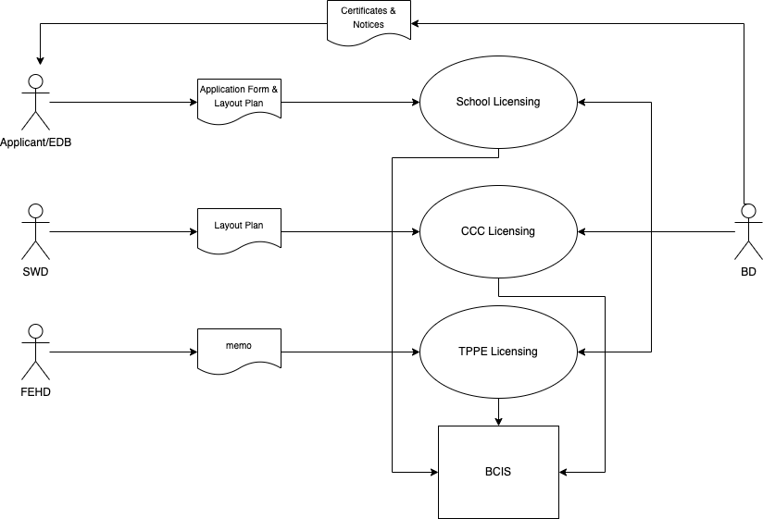

* + 1. Current System Hardware, Software and Network

For licensing of School, CCC and TPPE, the data is stored in BCIS. For details of BCIS input screen, please refer to Appendix 1.

High level system overview:

|  |  |
| --- | --- |
| Subsystem | Function |
| BCIS | BCIS is the system to maintain all building safety information in BD. When BD officer receives application request of TPPEL, the officer needs to input required data into BCIS in order to create a new case. |

* + 1. Volumes and Frequencies

BD received a total of 2689, 3008, 3618 cases in relation to the license applications for EP, CCC and TPPEL in 2017, 2018 and 2019 respectively. There is a continuous rising trend on the number of license applications and it is anticipated that the estimated growth rate of the applications is about 10% per annum.

* + 1. Interface with Other Systems

There is no external interface with other systems.

## CURRENT BUSINESS MODEL(CURRENT PROCESS WORKFLOW)

### New or Alteration or Extension Application of School Registration

Step 1. Applicant or EB (in case of alteration application) submits application form and 4 copies of layout plan to BD. For new application, the form is form A2 (School Registration) / E2 (Extension of School Premises). For alteration application, EDB refers memo to BD.

Step 2. BD technical officer and professional officer conduct desktop study and site inspection

Step 3. If works completed and building safety requirements are compiled with, technical officer compiles a report and endorsed by professional officer and senior officer.

Step 4. BD issues notices and certificates accompanied with endorsed plan to applicant

**Below are some common scenarios:**

Scenario 1 – Building safety requirements are not compiled with and no objection by BD

Step 1. Applicant submits application form and 4 copies of layout plan to BD. For new application, the form is form A2 (School Registration) / E2 (Extension of School Premises). For alteration application, EDB refers memo to BD.

Step 2. BD technical officer and professional officer conduct desktop study and site inspection

Step 3. If building safety requirements are not compiled with, BD sends LoR to applicant

Step 5. Applicant reports completion of works and informs BD for compliance checks

Step 6. BD technical officer and professional officer conduct compliance inspection and document check

Step 7. If works completed and building safety requirements are complied with, technical officer compiles a report and endorsed by professional officer and senior officer. BD issues notices and certificates accompanied with endorsed plan to applicant. Otherwise, a revised LoR will be sent to applicant to continue the works

Scenario 2 – Building safety requirements are not compiled with and objection by BD

Step 1. Applicant submits application form and 4 copies of layout plan to BD. For new application, the form is form A2 (School Registration) / E2 (Extension of School Premises). For alteration application, EDB refers memo to BD.

Step 2. BD technical officer and professional officer conduct desktop study and site inspection

Step 3. BD objects the application and technical officer compiles a report and endorsed by professional officer and senior officer and chief officer

Step 4. BD sends objection letter together with other building safety requirements to applicant

Step 5. If the objection items and building safety are resolved, Applicant reports completion of works and informs BD for compliance checks

Step 6. BD technical officer and professional officer conduct compliance inspection and document check

Step 7. If works completed and building safety requirements are complied with, technical officer compiles a report and endorsed by professional officer and senior officer. BD issues notices and certificates accompanied with endorsed plan to applicant. Otherwise, a revised LoR will be sent to applicant to continue the works

**Workflow Diagram for New Application of School Registration:**

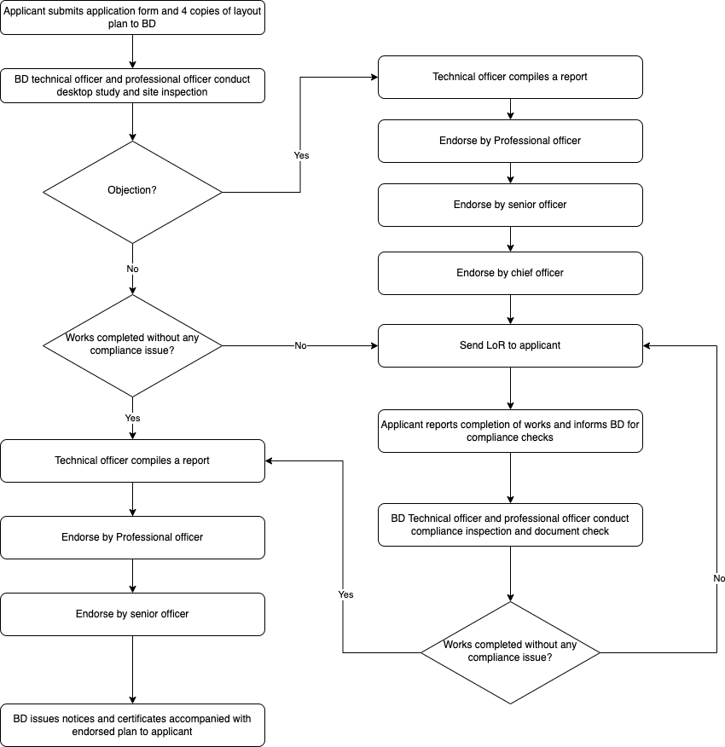

**Workflow Diagram for Alteration Application of School Registration:**

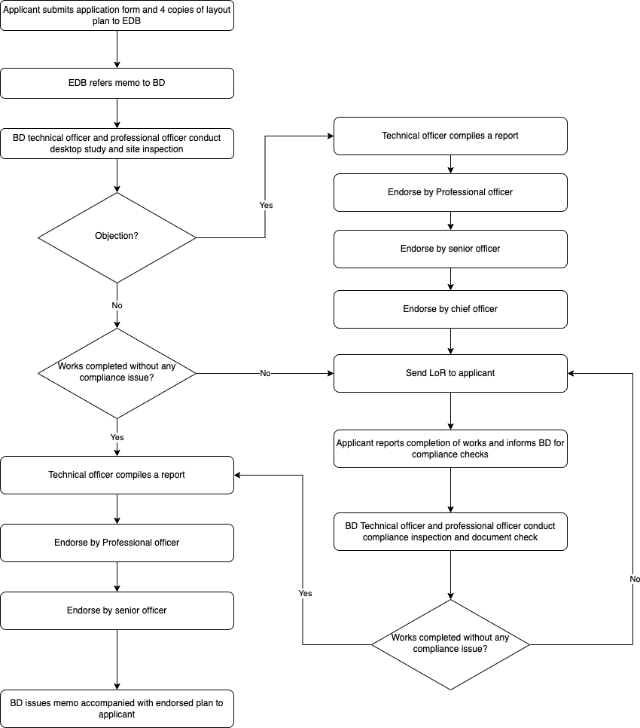

### New or Alteration Application of Child Care Centre

Step 1. Applicant submits application form and 4 copies of layout plan to SWD and SWD refers them to BD. For new application, the form is form CCCAI/C2.

Step 2. BD technical officer and professional officer conduct desktop study and site inspection

Step 3. If works completed and building safety requirements are compiled with, technical officer compiles a report and endorsed by professional officer and senior officer.

Step 4. BD issues notices and certificates accompanied with endorsed plan to applicant/ SWD

**Below are some common scenarios:**

Scenario 1 – Building safety requirements are not compiled with and no objection by BD

Step 1. Applicant submits application form and 4 copies of layout plan to SWD and SWD refers them to BD. For new application, the form is form CCCAI/C2.

Step 2. BD technical officer and professional officer conduct desktop study and site inspection

Step 3. If building safety requirements are not compiled with, BD sends LoR/ memo to applicant/ SWD

Step 5. Applicant reports completion of works and informs BD for compliance checks

Step 6. BD technical officer and professional officer conduct compliance inspection and document check

Step 7. If works completed and building safety requirements are complied with, technical officer compiles a report and endorsed by professional officer and senior officer. BD issues notices and certificates accompanied with endorsed plan to applicant/ SWD. Otherwise, a revised LoR/ memo will be sent to applicant/ SWD to continue the works

Scenario 2 – Building safety requirements are not compiled with and objection by BD

Step 1. Applicants submits application form and 4 copies of layout plan to SWD and SWD refers them to BD. For new application, the form is form CCCAI:C2.

Step 2. BD technical officer and professional officer conduct desktop study and site inspection

Step 3. BD objects the application and technical officer compiles a report and endorsed by professional officer and senior officer and chief officer

Step 4. BD sends objection letter / memo together with other building safety requirements to applicant/ SWD

Step 5. Applicant reports completion of works and informs BD for compliance checks

Step 6. If the objection items and building safety are resolved, BD technical officer and professional officer conduct compliance inspection and document check

Step 7. If works completed and building safety requirements are complied with, technical officer compiles a report and endorsed by professional officer and senior officer. BD issues notices and certificates accompanied with endorsed plan to applicant/ SWD. Otherwise, a revised LoR/ memo will be sent to applicant/ SWD to continue the works

**Workflow Diagram for New or Alter Application of Child Care Centre:**

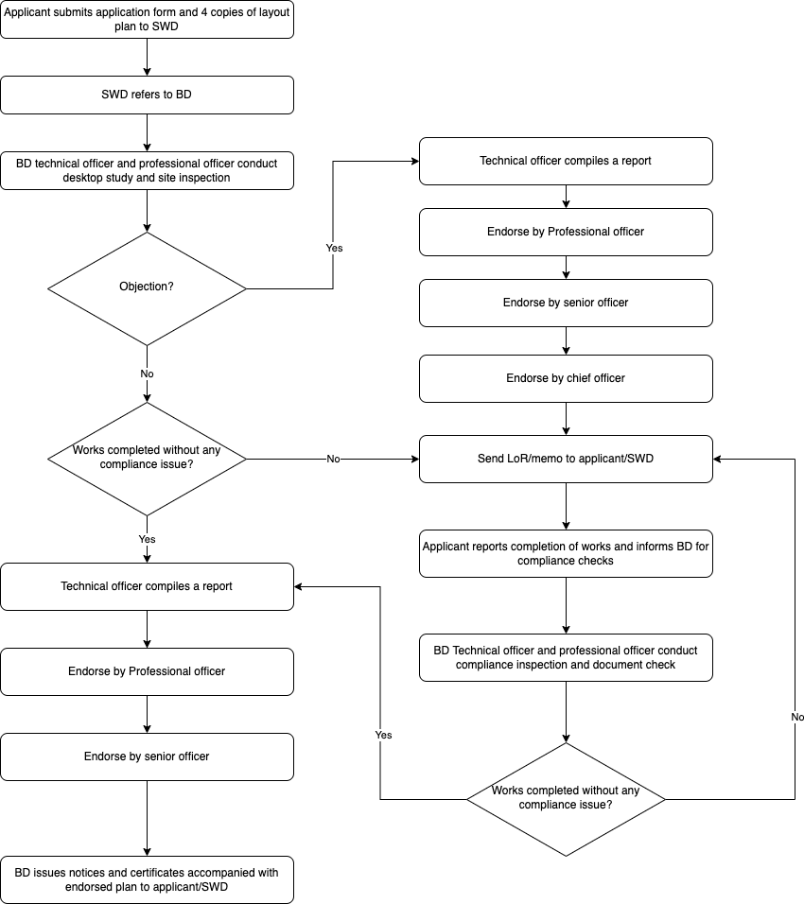

### New Application of Temporary Places of Public Entertainment

Step 1. Applicant submits application form and layout plan to FEHD and FEHD refers to BD.

Step 2. BD officer inputs data into BCIS

Step 3. BD technical officer and professional officer conduct desktop study and site inspection

Step 4. If works completed and building safety requirements are compiled with, technical officer compiles a report and endorsed by professional officer and senior officer.

Step 5. BD issues memo to FEHD

**Below are some common scenarios:**

Scenario 1 – Building safety requirements are not compiled with and no objection by BD

Step 1. Applicant submits application form and layout plan to FEHD and FEHD refers to BD.

Step 2. BD officer inputs data into BCIS

Step 3. BD technical officer and professional officer conduct desktop study and site inspection

Step 4. If building safety requirements are not compiled with, BD sends memo to FEHD

Step 5. Applicant submits revised plan to FEHD and informs BD for compliance checks

Step 6. If building safety requirements are complied with, a revised memo will be sent to FEHD to continue the works

Scenario 2 – Building safety requirements are not compiled with and objection by BD

Step 1. Applicant submits application form and layout plan to FEHD and FEHD refers to BD.

Step 2. BD officer inputs data into BCIS

Step 3. BD technical officer and professional officer conduct desktop study and site inspection

Step 4. BD objects the application and technical officer compiles a report and endorsed by professional officer and senior officer and chief officer

Step 5. BD sends objection memo together with other building safety requirements to FEHD

Step 6. Applicant submits revised plan to FEHD and informs BD for compliance checks

Step 7. If the objection items and building safety are resolved, BD technical officer and professional officer conduct compliance inspection and document check

Step 8. If building safety requirements are complied with, a revised memo will be sent to FEHD to continue the works

**Workflow Diagram for New or Alteration Application of Temporary Places of Public Entertainment:**

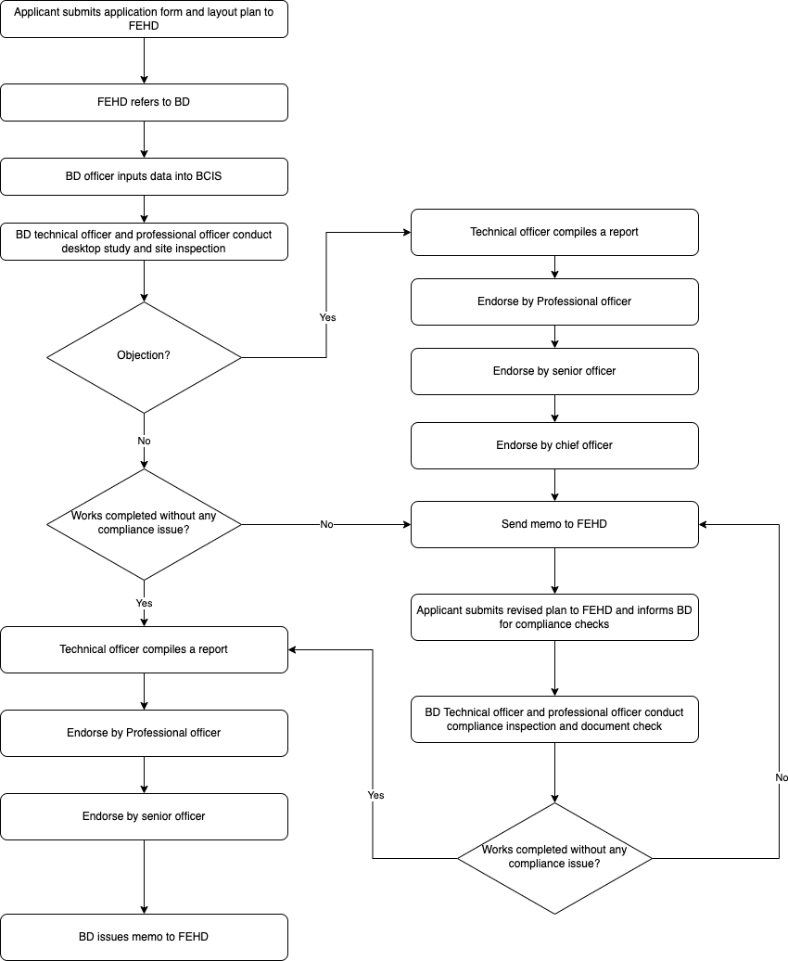

## CURRENT PROBLEMS AND ISSUES

The following table shows the problems and issues of current system.

|  |  |
| --- | --- |
| Item | Description |
| 001 | Long processing time of various licenses as it mainly relies on paper processing |
| 002 | Lack of management reports and statistics |
| 003 | No systematic and organized repository of application records, supporting documents and issuing certificates and notices |
| 004 | No integration with other systems |

# Appendix 1 – BCIS input screen

/Users/jeffreyman/Downloads/bd/TPCS/from bd/existing workflows/BCIS input screen.pdf